SIMATS ENGINEERING (SAVEETHA SCHOOL OF ENGINEERING)
Course Code & Title: | ECA5604 -5G/6G COMMUNICATION | Course Faculty: | Dr.K.Sathish
Student Name: | Velamuri Bhanodhay | Reg. No.: | 192412330
Dept / Batch: | BE.ECE / 2024 | Date: | 15/7/2026
Lab Observation

Experiment 1 : Simulation of FDMA in MATLAB

Objective 1:

To simulate an FDMA system by allocating individual frequency channels to multiple users
and determine the channel bandwidth assigned to each user.

Matlab Code:

clc;clear
fs=1000; t=0:1/fs:1; fc=[100 300 500];
m=sin(20*pi*t);

subplot(211)
plot(t,m.*cos(2*pi*fc'.*t),'LineWidth',1)
grid on
title('FDMA Channel Allocation')
xlabel('Time (s)'),ylabel('Amplitude')

subplot(212)
bar(1:3,200*ones(1,3))
grid on
title('Channel Bandwidth per User')
xlabel('Users'),ylabel('Channel Bandwidth (kHz)')

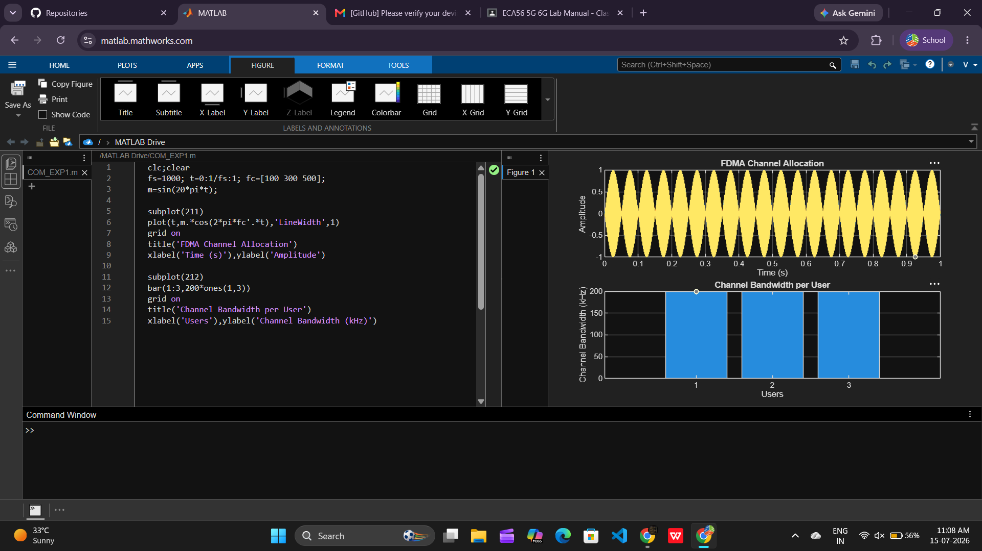
Objective 2:

To calculate the data rate achieved by each user in the FDMA system based on the allocated
channel bandwidth.

Matlab Code:

clc;clear;close all;
U=3; R=200*log2(2)*ones(1,U);

disp('User Data Rate (kbps)')
disp([(1:U)' R'])

bar(1:U,R)
grid on
xlabel('Users')
ylabel('Data Rate (kbps)')
title('FDMA Data Rate for Each User')

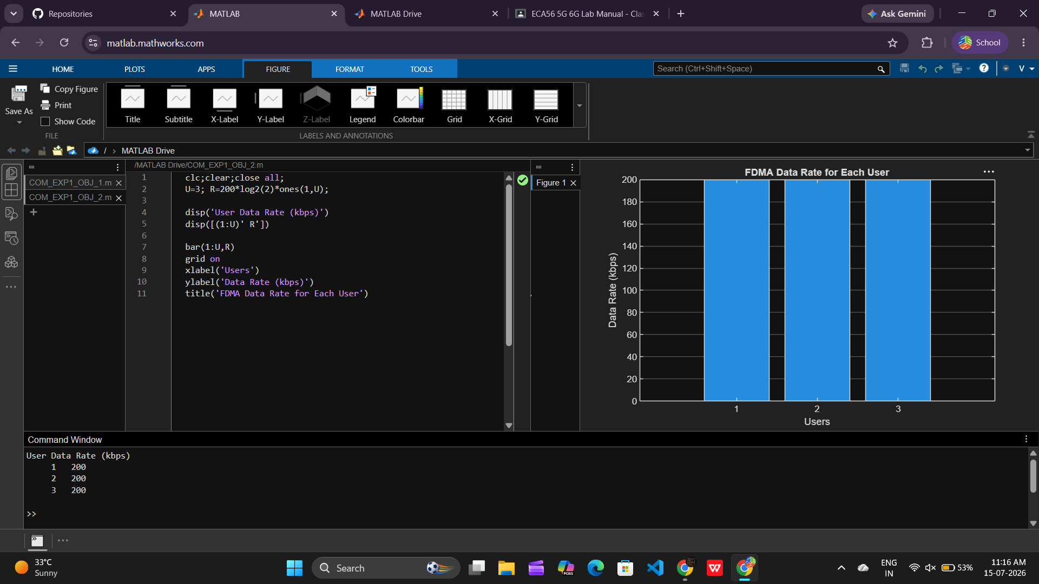

Objective 3:

To evaluate the communication quality of the FDMA system by calculating the Signal-to-
Noise Ratio (SNR) for different users.

Matlab Code:

clc;clear
Pn=[0.1 .05 .01];
S=10*log10(1./Pn);

disp('User Noise Power(W) SNR(dB)')
disp([(1:3)' Pn' S'])

bar(1:3,S)
grid on
xlabel('Users')
ylabel('SNR (dB)')
title('Signal-to-Noise Ratio of FDMA Users')

